Project Design Phase-II Technology Stack (Architecture & Stack)

|  |  |
| --- | --- |
| Date | 19 November 2023 |
| Project Name | Detecting COVID-19 From Chest X-Rays Using Deep Learning Techniques |
| Maximum Marks | 4 Marks |

Technical Architecture:

The Deliverable shall include the architectural diagram as below and the information as per the table1 & table 2

Example: Order processing during pandemics for offline mode

Reference: <https://developer.ibm.com/patterns/ai-powered-backend-system-for-order-processing-during-pandemics/>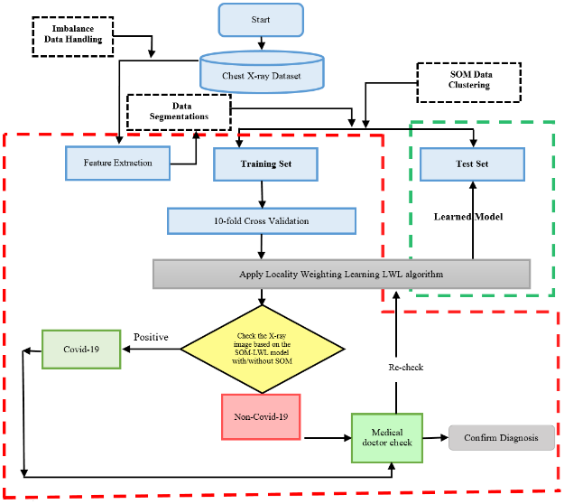

Guidelines:

1. Upload the clear image of the x-ray.
2. Only upload the x-ray image which you want to check .

Table-1 : Components & Technologies:

|  |  |  |  |
| --- | --- | --- | --- |
| **S.No** | **Component** | **Description** | **Technology** |
| 1. | User Interface | User just have to upload the image of the x-ray and check that if that if the person is suffering from covid or not. | Flask, HTML ,Css, JavaScript |
| 2. | Application Logic | we have build an Cnn model | VGG-16, CNN MODEL |
| 3. | Database | We have uses local host for database | Local host |
| 4. | File Storage | We have store the file in our local system |  |
| 5. | Machine Learning Model | We have build this model to check that if the person is suffering from covid or not or with pneumonia | We have build CNN Model |

Table-2: Application Characteristics:

|  |  |  |  |
| --- | --- | --- | --- |
| **S.No** | **Characteristics** | **Description** | **Technology** |
| 1. | Open-Source Frameworks | We have used python for our project | TensorFlow,Scikit-learn, flask |
| 2. | Availability | Justify the availability of application (e.g. use of load balancers, distributed servers etc.) | Technology used |
| 3. | Performance | Design consideration for the performance of the application (number of requests per sec, use of  Cache, use of CDN’s) etc. | Technology used |

References:

<https://c4model.com/>

<https://developer.ibm.com/patterns/online-order-processing-system-during-pandemic/> <https://www.ibm.com/cloud/architecture>

<https://aws.amazon.com/architecture>

<https://medium.com/the-internal-startup/how-to-draw-useful-technical-architecture-diagrams-2d20c9fda90d>